Hosted Communications Services
Using the Cloud to communicate

The Cloud is reshaping the future of communications services

Hosted applications such as IP Centrex, SIP Trunking and Hosted Contact Centre solutions are changing not just the way we all communicate, but the way we work – in the office, at home and on the move. Over 70% of UK businesses already use at least one fully deployed cloud-based application*.

* Businesses of 50 or more users. Source: ‘Cloud is becoming the new normal’ #SP02U, June 2012

Hosted Communications Services can take your business to the next level
With traditional voice services in decline, now’s the time to evolve your business and make the cloud work for you. We offer the latest technology, enabling you to react quickly to market opportunities, but without the challenges of having to manage costly resources and maintain levels of expertise in-house. Improve your customer service so you can respond quickly and flexibly to meet demand.

Our Hosted Communications Services are embedded within a next-generation network, providing built-in quality of service, security and resilience as standard, backed by extensive expertise, resources and reach.

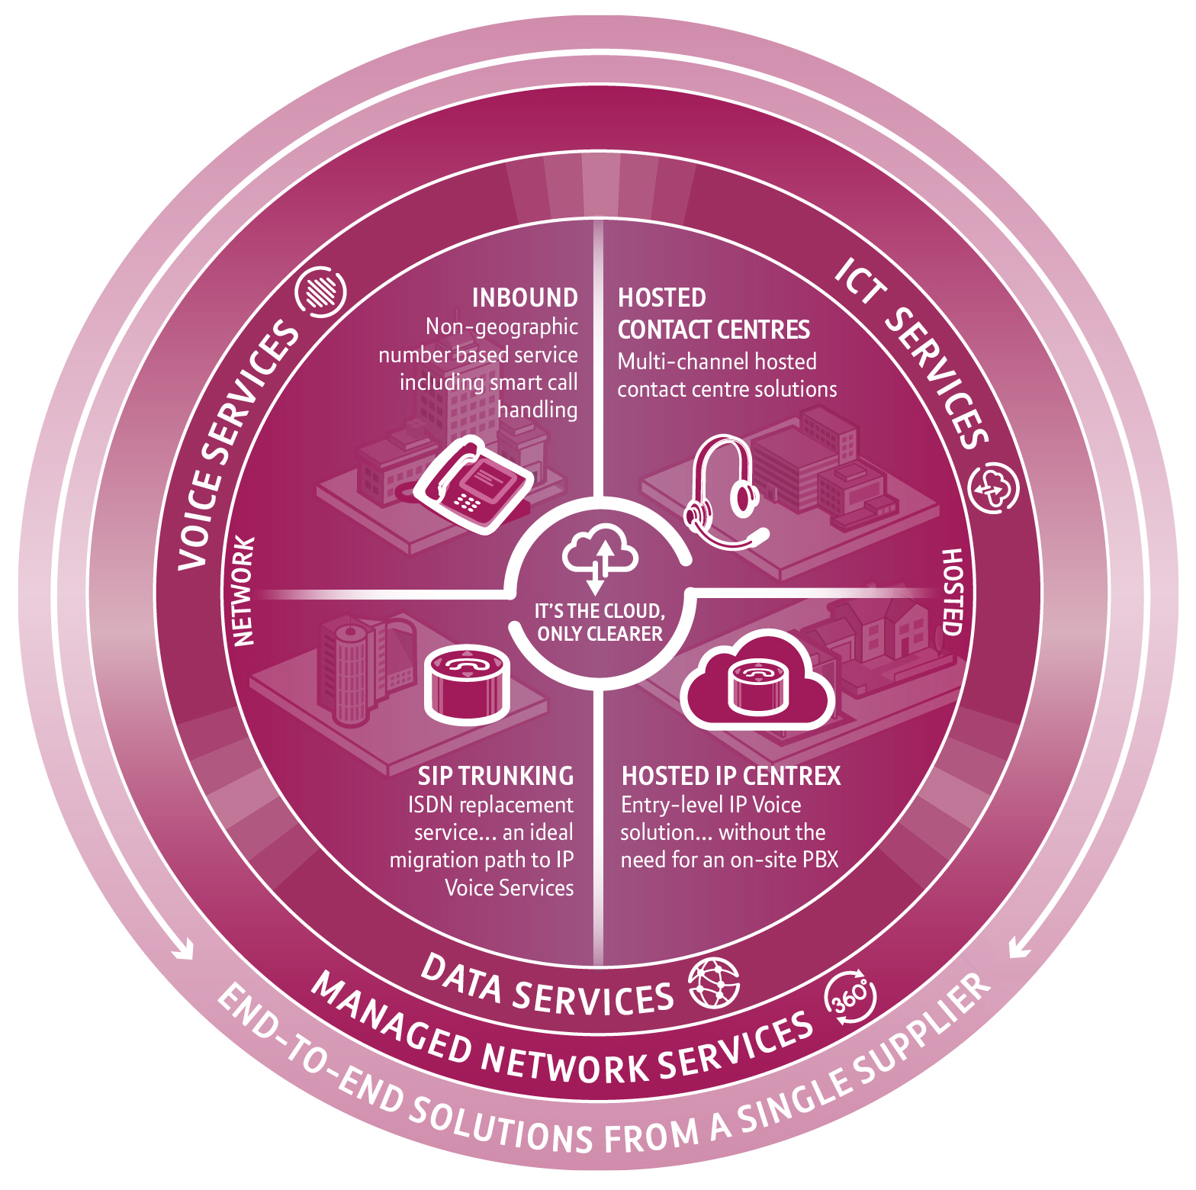

Make the most of the opportunities in this evolving world of IP

Our Hosted Communications Services portfolio delivers more of the smart business tools you need, offering practical, cost-effective solutions that deliver high performance and reliability.

SIP Trunking
SIP Trunking bridges legacy and next generation voice technology, providing a simple first step towards unified communications without any major investment or disruption. The service allows you to keep your existing PBX and handsets, but benefit from enhanced functionality and significantly lower costs – in many cases up to 50% savings. It’s the ideal replacement for ISDN, offering greater flexibility, business continuity as standard, and can scale to suit all businesses.

Hosted IP Centrex
This is our industry-leading unified communications solution bringing together voice, video, presence and collaboration tools on any device, anywhere in the UK. As well as enabling smarter working, it offers lower call costs and advanced call handling. Because the service is hosted and fully managed, there’s no need for a PBX, no major up-front investment and operates on a pay-as-you-grow basis.
It also integrates with our data connectivity products.

Hosted Contact Centres
Hosted Contact Centres (HCC) can be deployed quickly and simply. Our solution offers all the benefits of a high-performance contact centre – including voice, email, SMS, social networking and automated access – without the associated set-up costs of an on-premise solution. Our flexible commercials and scalability mean you can enjoy agile, responsive enterprise grade capabilities that will help you deliver a great customer experience and support your business growth ambitions.

Inbound services
Our Inbound Calls services give you all the flexibility of non-geographic numbers, smart call handling, dynamic call stats and analysis. You can have a Freephone, fixed rate or premium rate number that can be routed anywhere in the UK. We use a dedicated, high capacity, fully resilient network means you can choose how, when or where to scale up or down to match call demand – giving you complete control. And you can make the most of our inbound and outbound calls services by combining them to get even better rates.

Version: 1_310114

