IP EXCHANGE PRE-PAY HANDBOOK

IP EXCHANGE
An IP Clearinghouse Solution from BT Wholesale

- OUTLINE OF THE PRE-PAY SERVICE 3
- SCOPE 3
- SERVICE EXCLUSIONS 3
- PRE-PAY ATTRIBUTES 3
  - THRESHOLD OPTIONS 3
  - THRESHOLD ALERTS 5
  - LOW BALANCE ALERTS 5
  - CRITICAL BALANCE ALERTS 5
  - SUSPENSION OF SERVICE NOTIFICATION 5
  - SERVICE RE-ACTIVATION NOTIFICATION 6
  - PORT RENTAL CHARGES 6
- PRICING 6
- BILLING 6
- VAT EXEMPT CUSTOMERS 7
- PAYMENTS 8
  - CHAPS PAYMENTS 8
- PRE-PAY WEB PORTAL 8
- PRE-PAY –E-BILLING SERVICE 9
- ORDERING PROCESS AND PROVISION 9
- USING THE BTW PREPAY PORTAL 10
- MANAGE CONTACTS 13
- FAULT HANDLING AND REPAIR 13
- COMPLAINT HANDLING 13
- GENERAL ENQUIRIES 13
- ADDITIONAL INFORMATION 14
- GLOSSARY OF TERMS 14

OUTLINE OF THE PRE-PAY SERVICE

IP Exchange is a product from BT Wholesale positioned to meet the requirement of the emerging IP communications market for a clearing house which connects together disparate IP islands, supporting VoIP to VoIP calling, also calls to and from the PSTNs and international networks.

The IP Exchange Pre-Pay service facility allows Customers who don’t have previous credit history with BT to take advantage of the IP Exchange Service. The Pre-Pay facility minimises the BT Wholesale Credit Vetting process or allows Customers who fail Credit Vet to still connect and use the IP Exchange service.

SCOPE

The Pre-Pay facility enables the same services that exist with IP Exchange Post Pay. The Post pay service processes are used to facilitate the provisioning and modification (L2C) of the Service, as are the Trouble Ticketing (T2R) process, and number management processes (Number Sub-Allocation)

SERVICE EXCLUSIONS

Outlined below are numbers that are not currently available for dialling into the IP Exchange Pre-Pay Service and BT makes no guarantee to make these available in the future:

  - 0808, 0500 codes (both Inbound and Outbound, this is due to the nature of the payment flows)
  - Service codes that are specific to BT Retail
  - Calls to numbers barred by the Customer’s Profile

PRE-PAY ATTRIBUTES

The initial amount that a Customer needs to have in its Pre-Pay account will be determined by BT based on the Customer’s Forecast.

Threshold Options

Based on their Forecast, Customers shall be placed in their respective Pre-Pay Threshold Bands. BT can reassign a customer to a new Threshold band and Customers should also contact the BTW Account manager if they consider they need to be moved to a different band. The Pre-Pay Threshold Banding will determine what the Customers Pre-Pay account balance will be:

Name | Minimum balance in pounds | Low balance Alert (50% of balance left) | Critical balance Alert (15% of balance left) | Suspension (5% of balance left)
Band 1 | 5000 | 2500 | 750 | 250
Band 2 | 10000 | 5000 | 1500 | 500
Band 3 | 15000 | 7500 | 2250 | 750
Band 4 | 20000 | 10000 | 3000 | 1000
Band 5 | 25000 | 12500 | 3750 | 1250
Band 6 | 30000 | 15000 | 4500 | 1500
Band 7 | 35000 | 17500 | 5250 | 1750
Band 8 | 40000 | 20000 | 6000 | 2000
Band 9 | 45000 | 22500 | 6750 | 2250
Band 10 | 50000 | 25000 | 7500 | 2500
Band 11 | 55000 | 27500 | 8250 | 2750
Band 12 | 60000 | 30000 | 9000 | 3000

Band 13 | 65000 | 32500 | 9750 | 3250
Band 14 | 70000 | 35000 | 10500 | 3500
Band 15 | 75000 | 37500 | 11250 | 3750
Band 16 | 80000 | 40000 | 12000 | 4000
Band 17 | 85000 | 42500 | 12750 | 4250
Band 18 | 90000 | 45000 | 13500 | 4500
Band 19 | 95000 | 47500 | 14250 | 4750
Band 20 | 100000 | 50000 | 15000 | 5000
Band 21 | 105000 | 52500 | 15750 | 5250
Band 22 | 110000 | 55000 | 16500 | 5500
Band 23 | 115000 | 57500 | 17250 | 5750
Band 24 | 120000 | 60000 | 18000 | 6000
Band 25 | 125000 | 62500 | 18750 | 6250
Band 26 | 130000 | 65000 | 19500 | 6500
Band 27 | 135000 | 67500 | 20250 | 6750
Band 28 | 140000 | 70000 | 21000 | 7000
Band 29 | 145000 | 72500 | 21750 | 7250
Band 30 | 150000 | 75000 | 22500 | 7500
Band 31 | 155000 | 77500 | 23250 | 7750
Band 32 | 160000 | 80000 | 24000 | 8000
Band 33 | 165000 | 82500 | 24750 | 8250
Band 34 | 170000 | 85000 | 25500 | 8500
Band 35 | 175000 | 87500 | 26250 | 8750
Band 36 | 180000 | 90000 | 27000 | 9000
Band 37 | 185000 | 92500 | 27750 | 9250
Band 38 | 190000 | 95000 | 28500 | 9500
Band 39 | 195000 | 97500 | 29250 | 9750
Band 40 | 200000 | 100000 | 30000 | 10000
Band 41 | 205000 | 102500 | 30750 | 10250
Band 42 | 210000 | 105000 | 31500 | 10500
Band 43 | 215000 | 107500 | 32250 | 10750
Band 44 | 220000 | 110000 | 33000 | 11000
Band 45 | 225000 | 112500 | 33750 | 11250
Band 46 | 230000 | 115000 | 34500 | 11500
Band 47 | 235000 | 117500 | 35250 | 11750
Band 48 | 240000 | 120000 | 36000 | 12000
Band 49 | 245000 | 122500 | 36750 | 12250
Band 50 | 250000 | 125000 | 37500 | 12500
Band 51 | 255000 | 127500 | 38250 | 12750
Band 52 | 260000 | 130000 | 39000 | 13000
Band 53 | 265000 | 132500 | 39750 | 13250
Band 54 | 270000 | 135000 | 40500 | 13500
Band 55 | 275000 | 137500 | 41250 | 13750
Band 56 | 4000 | 2000 | 600 | 200
Band 57 | 3000 | 1500 | 450 | 150
Band 58 | 2000 | 1000 | 300 | 100
Band 59 | 1000 | 500 | 150 | 50
Band 60 | Internal Test | Internal Test | Internal Test | Internal Test

PLEASE NOTE: Band 56-59 lower values introduced to assist new CP service. It is recommended that as soon as volumes increased CPs should move to more appropriate Threshold bands 1–55. Customer’s Threshold bands can be easily changed to reflect their usage.

Threshold Alerts

The following automated Threshold email alerts will be supported:

  - Low balance alert – 50%
  - Critical balance alert – 15%
  - Suspension alert – 5%
  - Reactivation alert – 100% credit posted to Moneybox for a given Band received – generated after a suspension has occurred.

Where % is the band level minimum balance amount – for example BAND 1 is £5,000 the 50% Threshold alert process will be invoked at £2500.

The System has been designed to support multiple Customers’ nominated Email contact points. Please discuss the email Alert Contact Points with your BT Account manager to be set up on the system.

Warning: there is an inherent minimum 15 minute delay between the events being generated on BTW’s Billing systems and the email being received in a customer's email account. This can take much longer due to vagaries of Customer’s Email service provider – this is outside the control of BTW service.

Low Balance Alerts

- A low balance alert will be triggered when 50% of the value within the Customer’s assigned Pre- Pay Threshold Band has been reached by the Customer.

- To avoid disruption to their IP Exchange service, Customers are required to ensure that enough Pre-Pay funds are available in their Pre-Pay accounts to cover traffic spend by topping up their Pre-Pay accounts once a low balance alert has been received.

- The Customer’s nominated Email Alert contacts will receive this automated email alert.

Critical Balance Alerts

- A critical balance alert will be triggered when 15% of the value within the Customer’s assigned Pre-Pay Threshold Band has been reached by the Customer.

- To avoid disruption to their IP Exchange service, Customers are required to ensure that enough Pre-Pay funds are available in their Pre-Pay accounts to cover traffic spend by topping up their Pre-Pay accounts without delay once a critical balance alert has been received.

- The Customer’s nominated Email Alert contacts will receive this automated email alert.

Suspension of Service Notification

- A suspension alert will be triggered when 5% of the value within the Customer’s assigned Pre-Pay Threshold Band has been reached.

- The Customer’s nominated Email Alert contacts will receive this automated email alert.

- The BT Operations teams will initiate suspension of the Customer’s Pre-Pay account as soon as they have received a copy of the suspension alert email.

- Calls that were in progress at the time of the break-out call suspension will remain in progress until they terminate naturally.

- New call attempts to 999, 18000 and 112 will be unaffected.

- In order for the Customer’s Pre-Pay account to be re-activated the Customer will need to provide sufficient payment to GENERATE THE REACTIVATION NOTIFICATION email within 7 days of its Pre-Pay account being suspended. For example if you are a band 1 CP – you must top up your Moneybox to the 100% Thresholds value of £5,000 – service will not be resumed until you
receive the service Re-Activation notification. For further information on account suspension and reactivation, please refer to your Pre-Pay Agreement.

Service Re-Activation Notification

- Reactivation will only be triggered when 100% of the value of the Customer’s assigned Pre-Pay Balance is showing in the Customer’s Pre-Pay account. This will generate the Reactivation email alert to BT Operations and the customer’s email alert contact points.

- BT Operations reactivation will be only be available during Normal working hours, 08:30 to 17:00 hrs Monday to Friday, exclude Bank Holidays, and could take up to 5 working days to be completed from request of the Reactivation Notification being received.

- The Customer will be informed by email when its Pre-Pay account has been reactivated.

- It is very important that a Customer understands which Threshold band they are in – this will affect the payment they must make once the Suspension has been made to their account. Failure to update their moneybox with the 100% payment matching their Threshold Band will result in no Reactivation email being generated.

Port Rental Charges

- Port rental charges, as published in IPX Annex A rate card, are applied at the beginning of each month.
- It is important that at the beginning of each month Customers ensure that sufficient available funds exist within their Pre Pay account for both daily traffic spend requirements and for port rental charges. Failure to manage the Pre Pay account in the manner described above could result in the account progressing rapidly through the various balance / Threshold alerts (50% , 15%) thus not allowing BT to provide sufficient balance notification. Suspension of the Pre Pay account will/could occur if the deduction of monthly one off port rental charges reduces the Customer’s account to or below the 5% (Suspension) Threshold.

PRICING

  - Refer to the IP Exchange contract, Schedule 3, and Annex A rate card for pricing information, this is available at,
IP Exchange - Products & services | Pricing & Contracts

BILLING

  - Call Charges will be decremented against the Customer’s Pre-Pay account (MoneyBox) every 30 minutes.

  - Port Management Rental Charges will be decremented against the Customer’s Pre-Pay account on the first working day of each month.

  - PIA (Payment in Advance) - This will be requested to cover any set up charges / connection charges i.e. set up charges are one-off, non-recurring charges which will be decremented against the Customer’s Pre-Pay account prior to the Service Start Date.

  - The Normal service is that all Charges will be decremented inclusive of VAT.

  - A monthly statement will be issued to the Customer for these charges on the first day of the following month and it is recommended to sign up to e-billing so there is no delay in receipt of the statement and any supporting files.

  - The values in the Annex A and Annex B rate cards will be applicable to both post and pre-pay customers and be published exclusive of VAT. However, the applied rates for pre-pay customers will be VAT inclusive; all pence per minute values are rounded mathematically to three decimal places of a penny and all pence per call values to one decimal place of a penny. These rates will be applied on a per call basis with the final call charge rounded to the nearest tenth of a penny.

  - The end of month statement will display the total VAT element of your charges separately and for the usage element, a supporting .csv file breaking down the calls, minutes and charges by day, evening and weekend will be provided with the charges and prices being inclusive of VAT. Actual pence per minute and Pence per call values will not be shown but average prices will be provided. Please note that this will prove difficult to match back to the original rate card, particularly where a price has changed during a month, but reassuringly the other invoice elements will be reconcilable against customer data.

  - It is worth commenting further on the way prices are applied as the unavoidable effect of applying rates inclusive of VAT and the following rounding along with the aggregation of many individually priced calls on the month-end supporting documentation can make the displayed rate un- reconcilable against the Annex A and B rate cards. Examples are shown below that highlight that at times the applied rate appears slightly greater and at others slightly less when the displayed rate has VAT removed.
 | Day Rate | Inc VAT @ 20% | Applied Rates | Applied rate less VAT
Operator LCFA 0845 | 2.7214 | 3.2657 | 3.2660 | 2.7217
Operator LCFA 0845 setup fee (PPC) | 2.7000 | 3.2400 | 3.2000 | 2.6667
2p Operator 0844 NTS Calls (g9) | 2.2622 | 2.7146 | 2.7000 | 2.2500
3p Operator 0844 NTS Calls (g10) | 3.2390 | 3.8867 | 3.9000 | 3.2500
4p Operator 0844 NTS Calls (g11) | 4.3615 | 5.2338 | 5.2000 | 4.3333
5p Operator 0844/0871 NTS Calls (g6) | 5.2833 | 6.3399 | 6.3000 | 5.2500
Note:
The PDF (Bill Statement) will show the billing account no. as GFnnnnnnnn, the bill backup shows it as AUR06nnnnnnnn.

VAT EXEMPT CUSTOMERS

  - The system supports VAT exempt customers and will offer all calls VAT exempt such that all Call Charges will be decremented against the Customer’s Pre-Pay account (MoneyBox) every 30 minutes exclusive of VAT.
  - Port Management Rental Charges will be decremented exclusive of VAT each month.
  - All Charges raised against the Moneybox will be exclusive of VAT.
  - Any payments posted to the Moneybox will reflect actual deposits received.
- The supporting back-up file will now show VAT exempt amounts.

PAYMENTS

CHAPS payments

  - Customers are required to make regular Top Ups in Sterling using CHAPS payment services, allowing one banking day for any payments made by 2pm to be received by BTW and placed onto the Customer’s Pre-Pay account.

  - Any payment processed after 3pm should be considered too late for processing within the same banking day and the Customer must consider this when making their CHAPS payment.

  - Banking details to use are:

    - Account Name: BT NRC DD
    - Bank Sort Code: 20-00-00
    - Bank Account no. 10596159
- IBAN is: GB27 BARC 2000 0010 5961 59
- Swift code BARCGB22

  - Please quote in your Payment reference fields you’re BTW Pre-Pay Account number, as an example, 06nnnnnnnn or GFnnnnnnnn. Please refer also to the instructions on the Pre-Pay web portal for CHAPS payments.

  - It is recommended that when making payments, by CHAPS, an e-mail is sent to the following BT e-mail addresses rtrcc@bt.com and btw.prepay.admin.team@bt.com, can you please ensure the Payment instructions state the following:

CHAPS payment made for the BTW IPEX Prepay Billing Account no. 06xxxxxxxxx. Where 06xxxxxxxx or GF xxxxxxxx is your BTW Billing Account no.

  - See https://my.btwholesale.com//ipexprepay/ipexprepayMethods.do for advice re payments.

  - Customers are recommended to calculate the time it will take to clear a CHAPs bank transfer – to avoid Service Suspension.

Any enquiries regarding the collection of CHAPS payments should be referred to
btw.prepay.admin.team@bt.com.

PRE-PAY WEB PORTAL
  - Customers should request access to IP Exchange portal by registering on the http://www.btwholesale.com/ website. Having completed the online Registration, upon receipt of your welcome to service pack, please send an email to wolverhamptonnumberportability@bt.com (WCMC team) requesting access to the IP Exchange Prepay Portal – please quote your user id.
See section 12 for screen shots on registering a new user id and accessing the Pre Pay Portal.

  - The IP Exchange Pre-Pay Web Portal Self Service Tool provides Customers with a secure environment to review spend history, available Pre-Pay account balance, view payments and adjustments completed against the account.

  - The option View Contacts provides you with the list of Threshold Email alert destinations – max 5; if you wish to amend these email address recipients please contact your account manager to make the changes required.

  - The Pre-Pay Web Portal is available at www.btwholesale.com.

  - The Pre-Pay Web Portal gives customers the ability to:
View the last date and time of your last Threshold email alert generated
View which Threshold band you are placed
Download the Latest handbook – which includes the Threshold bands.
View last 6 months history of Threshold Email alerts generated

PRE-PAY –E-BILLING SERVICE

The IP Exchange Pre-Pay Web Portal Self Service Tool provides CPs with the ability to view their previous Bills and the 'monthly summarised usage back-up data' also known as .dat files.

  - The Pre-Pay Web Portal is available at www.btwholesale.com see E-Billing option.

  - See Section 12 for the E-Billing Portal screen images.

                - E-Billing files will be available on day 3 of the month – they may be available earlier but this is not
guarantee. If your E-Billing data is not available on day 3 of the new month please contact your
Account Manager. WARNING: the E-Billing service is only configured for a specific CP Portal
account – any attempt to view e- Billing from another CP Account will not be allowed. This is
required to provide strict controls to the CP between departments / teams.

ORDERING PROCESS AND PROVISION

  - Standard IP Exchange Processes are used to order and provision Customers joining the IP Exchange Pre-Pay Service.

  - Your Account Manager (or Sales Specialist) will be able to assist you in the ordering process in the first instance and will have the necessary Contractual documentation, and Customer Requirements Form (CRF) to gather your requirements.

  - A Technical Account Manager (TAM) will be appointed to support the Customer through contract signature and where necessary any Compatibility Testing and associated provision activity.

  - Customers should request access to www.btwholesale.com in the first instance, and then the IP Exchange Prepay Application upon receipt of the welcome to service pack.

USING THE BTW PREPAY PORTAL

First Time user - Customers will require access to IP Exchange Portal screens, CP should in the first instance register on the http://www.btwholesale.com/ website selecting REGISTER – following the instructions as an External CP – see screens below (process allows the new CP to SELECT IP Exchange Prepay services. Please note: by default ECOPLUS will also be provided to you.). On completing the form the system will generate a new user id – please keep a note of this.

Having completed the online Registration, upon receipt of your welcome to service pack, please send an email to wolverhamptonnumberportability@bt.com (WCMC team) requesting access to the IP Exchange Prepay Portal – please quote your user id.

WCMC team will contact you by email when you access to the Portal has been completed.

To enter the application CPs will login to www.btwholesale.com and enter the IP Exchange Prepay Application. The CPs should then select the options available as per the screen shots below:

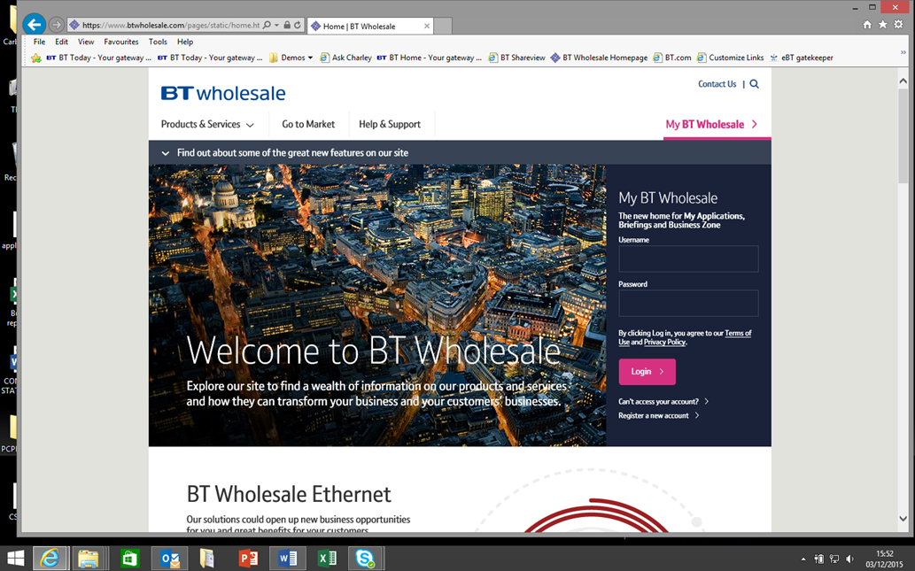
Enter
User ID and Password
Existing Customers - Login
New to BTW - Select Register now

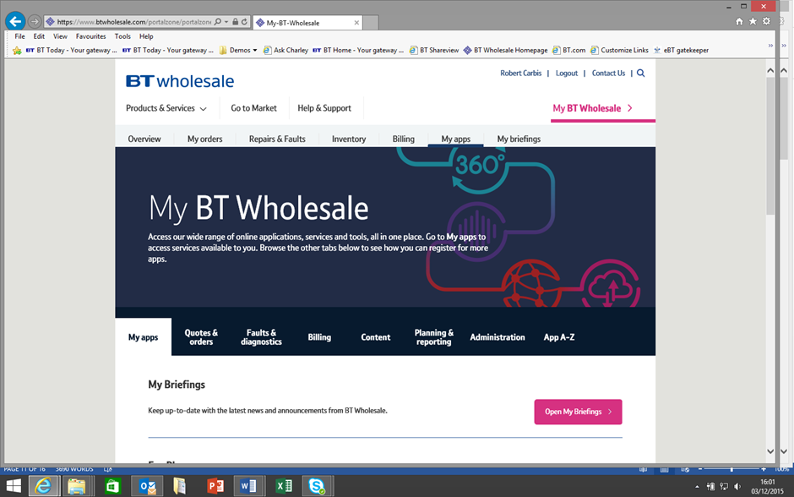
Select Apps

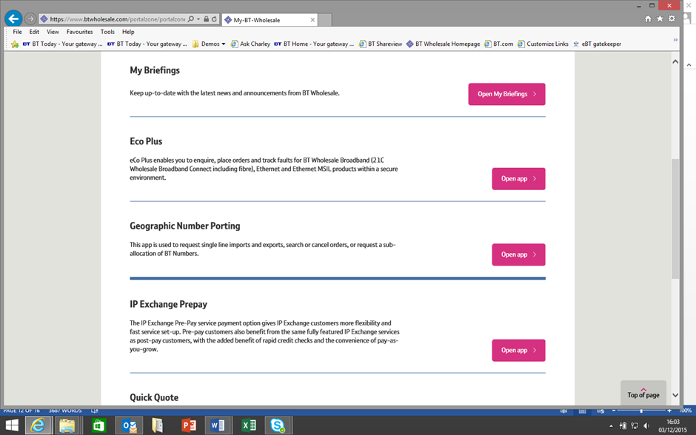
Select
IP Exchange

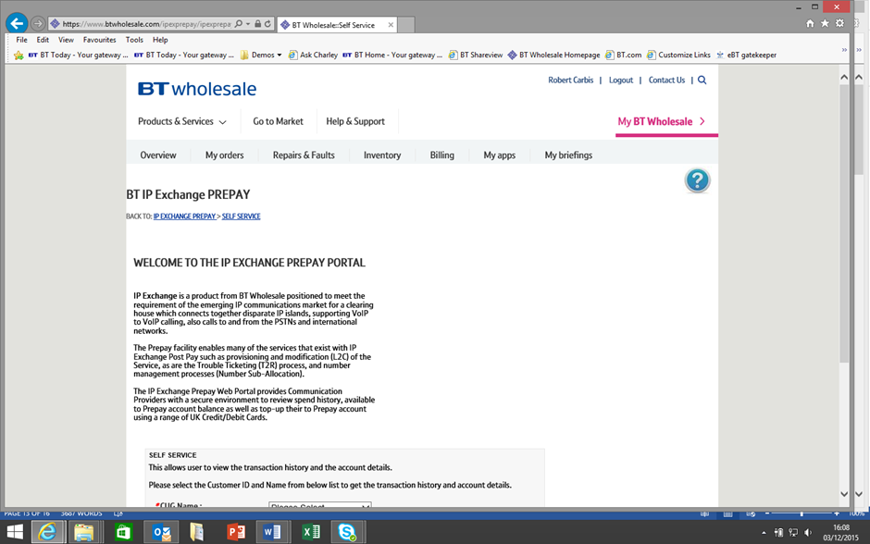

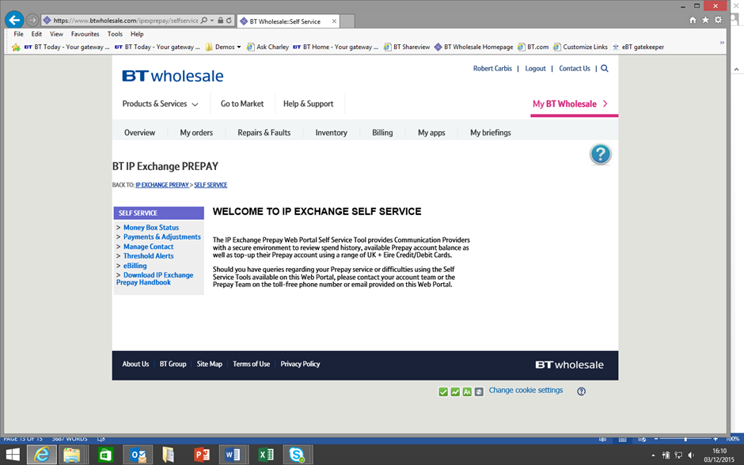

MANAGE CONTACTS
Customers can view their Prepay Threshold Alerts contact points by selecting MANAGE CONTACTS on the Self Service portal. Any changes requested should be requested with an email to
btw.prepay.admin.team@bt.com.

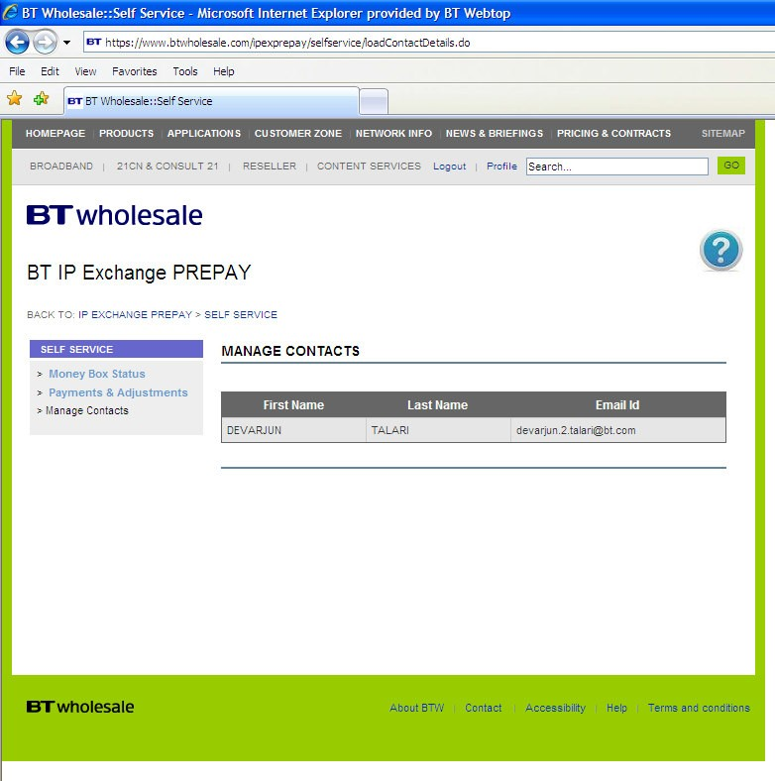

FAULT HANDLING AND REPAIR

  - Customers can report faults 24/7 throughout the year to the IP Exchange Customer Service Team on 0800 077 8247 option 2. The repair service desk will ensure that the customer has proven the fault away from their network before accepting the fault and then allocate a unique service identifier.

  - Repair handling teams will check IRAMS for known platform problems record the fault instance on SPACER-R and inform operations of the problems and request a resolution, SPACE-R will be updated and the customer notified of the service restoration on completion.

COMPLAINT HANDLING

  - Any complaint regarding the IP Exchange service should in the first instance be directed to the helpdesk for resolution on 0800 077 8247 Option 1. Should a customer remain dissatisfied they should follow the escalation procedure detailed in the CSP (Customer Service Plan).

GENERAL ENQUIRIES

  - The Portal is the point of contact for all general requests, however if difficulties are experienced in its use, please contact the Wolverhampton Helpdesk and can be contacted via e-mail using wolverhamptonipexchange@bt.com or via telephone on 0800 077 8247 Option 1, available 8:00am to 6pm Monday to Friday, excluding UK Bank Holidays.

  - The TAM function is the point of contact for any Network issues and can be contacted via e-mail using interconnect.team@bt.com. TAMs are available 9:00am to 5:00pm Monday to Friday, excluding UK Bank Holidays.

ADDITIONAL INFORMATION

  - IP Exchange is not a PSTN emulation services and customers should be aware that some PSTN features that are supported by ISUP signalling are not available with this product e.g. Ring Back when Free, Malicious Call Trace etc.

  - The following documentation is available from your BT Account team:

    - IP Exchange Product Handbook
    - Number Portability Handbook
    - Number Sub-Allocation Handbook
    - Pre-Test Description
    - Technical Service Description
    - Customer Service Plan (CSP)
    - Customer Requirements Form
    - Contract

Further information on IP Exchange can also be found at:
IP Exchange - Products & services | BT Wholesale

GLOSSARY OF TERMS

CHAPS | Clearing House Automated Payments System
CP | Content Provider
CR | Credit Card
CRF | Customer Requirements Form
CSP | Customer Service Plan
DB | Debit card
IP | Internet Protocol
PSTN | Public Switched Telephone Network
SIP | Session Initiation Protocol
TAM | Technical Account Manager
T2R | Trouble Ticket to resolve

